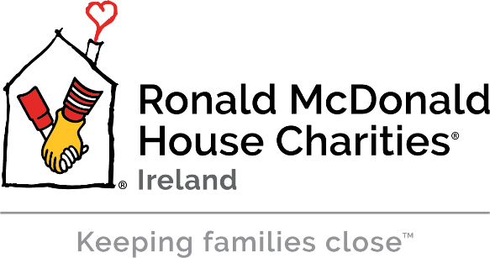

RMHC Ireland Corporate Partnerships Manager

Job Title: RMHC - Corporate Partnerships Manager
Job Location: The Ronald McDonald House Charity, Crumlin, Dublin 12
Reports to: Head of Operations
Purpose of Position:
The purpose of the position of Corporate Partnerships Manager at The Ronald McDonald House is to help manage RMHC fundraising activities and events, provide quality corporate donor stewardship and manage grant applications. The Corporate Partnerships Manager is the face and the voice of the Charity in all communications to current and future donors. This is a great opportunity for a motivated and inspirational individual from a corporate fundraising, CSR or business development background to join one of Ireland's leading charitable organisations and become a key member of a highly successful team.

Main Duties and Responsibilities:
- Develop and execute a Corporate Donor strategy
- Responsible for Corporate Relations
- Manage all grant applications
- Assist and maintain key operational databases
- Manage the charity’s interface with the public, including charity communications and publicity
- Carry out administrative tasks such as applying for grants and other sources of funding, manage budgets, gather data, prepare reports and manage all clerical work to meet the charity's needs.
- Assist in the delivery of local fundraising plans and activities against annual budgets, targets and plans.
- Attend local, regional and national fundraising activities and events as required.
- Respond to enquiries from the public, volunteers, fundraisers etc. (by phone, mail and in person)
including requests for information and material etc.
- Give talks and presentations to Corporate Organisations to increase awareness of and support for RMHC
- Be in attendance at all RMHC organised Fundraising Events in order to help deliver excellent events.

Other:
- To work within RMHC policies, procedures and to adhere to legal frameworks.
- To act in the best interests of the RMHC Ireland, sharing our story and acting as an ambassador for RMHC Ireland in line with our vision and mission.
- To carry out any other duties that may be assigned from time to time.

Families:
Looking after Families is always our primary responsibility. Being sensitive to and aware of their circumstances is essential at all times.
The above statements are intended to describe the general nature and level of work required for this position. They are not intended to be an exhaustive list of all responsibilities and activities required. We ask that the person in this position is able to respond with a flexible approach when tasks arise which are not specifically covered in this job description.
PERSON SPECIFICATION:
The ideal candidate will have a background in corporate fundraising, CSR or business development with several years’ experience in people management as a hands on, inspiring leader. You will possess demonstrable excellence in networking and influencing with the vision and mission of The Ronald McDonald House at the root of your motivations.
This position requires a dynamic, self-motivated and target driven individual who is creative and has an understanding of the sensitivities of the environment.
Knowledge/Experience:
• Minimum of 3-5 years’ experience in Sales with some experience of fundraising,
displaying an ability to achieve set targets/goals.
• A third level qualification in a relevant discipline.
• A full driving licence and access to a car as this position requires some travel.
• Flexibility to travel as required.

Skills/Competencies:
• A creative and innovative thinker.
- Demonstrable ability to achieve set targets/goals.
• Strong Interpersonal and communication skills, demonstrable experience in building and managing
key relationships and the ability to deal with a diverse range of people.
• Strong Organisational skills.
• Excellent IT skills.
• Excellent verbal and written communication skills.
• An understanding of budgets, finance and fundraising.
• The ability to negotiate and influence people.
• Excellent presentation skills.
• Direct marketing experience.
• Experience of marketing via Social Media.

Other Requirements:
- Good attention to detail and in particular accuracy in written work and data processing.
- Positive attitude particularly to learning new tasks and skills and being adaptable to change.
- The ability to work as part of a small team.
- Results focused.

